LA3 MAF Conversion BackFlow Fix….. 1/21/06

Version 3 Updated 11/18/06

Update Notes added 11/18/06:

Over time I started lowering the clip values in order improve the closed throttle idle even more after boost. I found the startup enrichments were being affected by the Maf clip and the motor would stall when first started warm or cold. So I added a very simple delay to the clip, only 5 new lines of EEC code. The Maf Clip will not be active for up to 90 secs after the motor is started. This allows enough time for normal A/F controls to take over and prevents any stalling. Also the delay can be adjust via the new .RDT parameter provided below. Still, if you adjust the MAF clip to low…the motor simply will not idle…so be care in adjusting the MAF clip.

Version 2 Updated 9/8/06

Update Notes added 9/8/06:

The .RDT scaling factor for the “backflow maf Clip vs Rpm” must be adjusted to match the Mass Air Multipler at P_1220 PCMX Address or 3220 real EEC address. Stock the Multipler is “1” ( 8000 hex ). Depending on how much you have setup your bin to flow, it can be set anywhere from “1” to flow a max of 32 #s or as high as “2” (ffff hex ) to flow a max of 64#s/min. The scaling of the Y axis should be set to 1024 for max flow of 64#s, which is what I provided in the example on page 5 of this doc. If you run the stock max flow number of 1, then the scaling show be 2048.

If your Mass Air Multipler is set between 1 & 2, then you need to do the math…..

Y scaling = 65535 / ( “Your Multipler” / 2 * 64 )

The sample numbers provided in the “backflow maf Clip vs Rpm” are good starting points, they worked for me. However recently I have reduced the #s / min even a little more.

By John K…..

Goal: After converting to a MAF sensor, some people (myself included) have experienced an idle stall immediately after a HIGH boost run. This would occur once the throttle is shut and the motor is allowed to idle with the clutch disengaged. The reason behind this is that air is actually backing out of the turbo ( i.e. Backflow ) and being measured by the MAF & EEC as actual flow into the motor. Keep in mind the VAM will indicate zero flow if air is flow backwards. This causes a rich A/F mixture. The Rich A/F causes stalling depending on how bad the back flow is. I was able to improve the issue by adjusting the Idle Mass flow Clip, MAX Decel PW and variety of other tweaks, but never totally eliminated it.

The back flow is affected by a number of factors. This includes:

- Size of MAF
- Distance between the turbo and MAF
- Use of a BOV or BPV may improve or worsen the behavior
- Size of turbo
- How much boost
- IC size

The Fix:

This drove me to add a closed throttle MAX MAF clip to the LA3 code.

Below are the .EEC code and .rdt additions. The Code uses P_2478 (same as the stock code) to determine what is a open vs. a closed throttle. The addition to the .RDT is the Function that determines what level to CLIP the MAF to based on the RPM (This may need tuning for your application). The code is resident at 8250 real hex address (6250 PCMX ), so you will need to check if you have used that address already ( most likely not ) and the Function is added at 8290. Add the .eec via the tuner emulator and then just use an editor to modify the .rdt. Then adjust the new the function MAF clip function to values I provided.

Results:

I have been running this about a week. The rich condition after boost is gone. The A/F meter returns to switching almost as soon as the fuel is turned back on from the Decel Fuel Shutoff function. The idle is almost identical as a VAM after high boost. Prior to this mod I had an occasional closed throttle backfire out the exhaust which is also gone.

If you give this a try, post feed back on this site on the results….I am thinking of adding a cold motor bypass to this. ( SEE VERSION 3 NOTES ADD ON PAGE 1 )
.EEC File of the code that needs to be added. FOR MAFS THAT STILL USE THE AIR MASS TRANSFER

all
0x4374 0xEF
0x4375 0xD9
0x4376 0x3E
0x8250 0xA0
0x8251 0x3E
0x8252 0x74
0x8253 0x99
0x8254 0x78
0x8255 0x49
0x8256 0xD3
0x8257 0x1F
0x8258 0xA0
0x8259 0x78
0x825A 0x34
0x825B 0x67
0x825C 0x01
0x825D 0x78
0x825E 0x24
0x825F 0x34
0x8260 0x88
0x8261 0x34
0x8262 0x90
0x8263 0xDB
0x8264 0x12
0x8265 0xA1
0x8266 0x90
0x8267 0x82
0x8268 0x32
0x8269 0xA0
0x826A 0x70
0x826B 0x34
0x826C 0xEF
0x826D 0x8C
0x826E 0xD6
0x826F 0x88
0x8270 0x38
0x8271 0x74
0x8272 0xD3
0x8273 0x03
0x8274 0xA0
0x8275 0x38
0x8276 0x74
0x8277 0xF0
end

.EEC File of the code that needs to be added. FOR MAFS THAT DOES NOT USE THE AIR MASS TRANSFER – STRAIGHT MAF TRANSFER TO #/MIN

All
0x433d 0x36
0x4374 0xEF
0x4375 0xD9
0x4376 0x3E
0x8250 0xFF
0x8251 0xFF
0x8252 0xFF
0x8253 0x99
0x8254 0x78
0x8255 0x49
0x8256 0xD3
0x8257 0x1F
0x8258 0xA0
0x8259 0x78
0x825A 0x34
0x825B 0x67
0x825C 0x01
0x825D 0x78
0x825E 0x24
0x825F 0x34
0x8260 0x88
0x8261 0x34
0x8262 0x90
0x8263 0xDB
0x8264 0x12
0x8265 0xA1
0x8266 0x90
0x8267 0x82
0x8268 0x32
0x8269 0xA0
0x826A 0x70
0x826B 0x34
0x826C 0xEF
0x826D 0x8C
0x826E 0xD6
0x826F 0x88
0x8270 0x38
0x8271 0x74
0x8272 0xD3
0x8273 0x03
0x8274 0xA0
0x8275 0x38
0x8276 0x74
0x8277 0xF0
end

ADDED BACKFLOW CLIP FUNCTION TO THE PCMX .RDT FILE

BEGIN FUNC "F_6290 Backflow MAF clip vs RPM"
ID "F_6290"
SIZE 7
XLABEL "Engine speed"
XADDRESS 0x6290
XTYPE 0x22
XSTEP -4
XUNITS "RPM"
XFORMAT "%2.0f"
XMATH 1
XSCALE 4.000000
XOFFSET 0.000000
XMIN -500.000000
XMAX 6000.000000
XADJUST 1
XALTADJUST 1
YLABEL "Max MAF"
YADDRESS 0x6292
YTYPE 0x22
YSTEP -4
YUNITS "#/min"
YFORMAT "%1.1f"
YMATH 1
YSCALE 1024.000000
YOFFSET 0.000000
YMIN -4.000000
YMAX 66.000000
YADJUST 1
YALTADJUST 1
END

Below are the values I am current running which seems to work fine. ( stock value is the blue , mine are in the black )

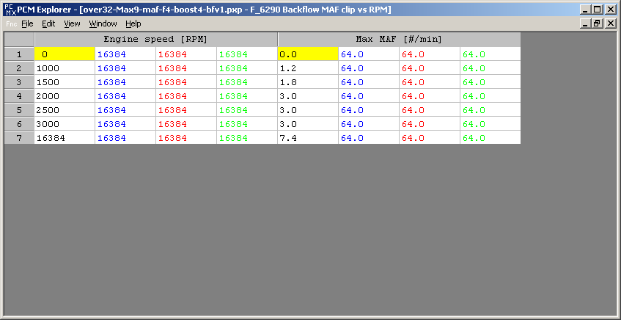
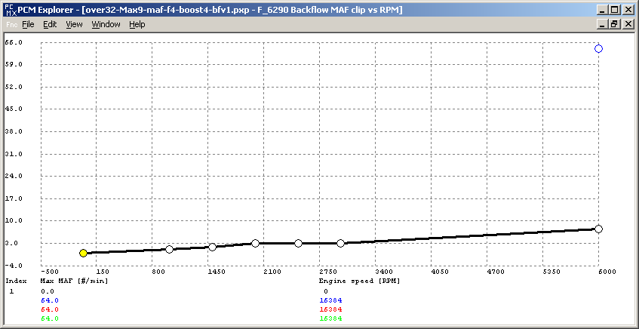

ADDED PARAMETER TO THE PCMX .RDT FILE TO ADJUST THE DECEL MAX PW FOR FUEL SHUTOFF. I raised this over the stock value.

BEGIN PARAM "P_048A Max pw Decel Fuel Shutoff nuetral"
ID "P_048A"
UNITS ""
ADDRESS 0x48A
TYPE 0x22
SCALE 262144.000000
OFFSET 0.000000
MATH 1
FORMAT "%4.5f"
ADJUST 1
ALTADJUST 1
END

BEGIN PARAM "P_048C Max pw Decel Fuel Shutoff drive"
ID "P_048C"
UNITS ""
ADDRESS 0x48C
TYPE 0x22
SCALE 262144.000000
OFFSET 0.000000
MATH 1
FORMAT "%1.5f"
ADJUST 1
ALTADJUST 1
END

Max pw decal for Fuel Shutoff ( stock value is the blue , mine are in the black )
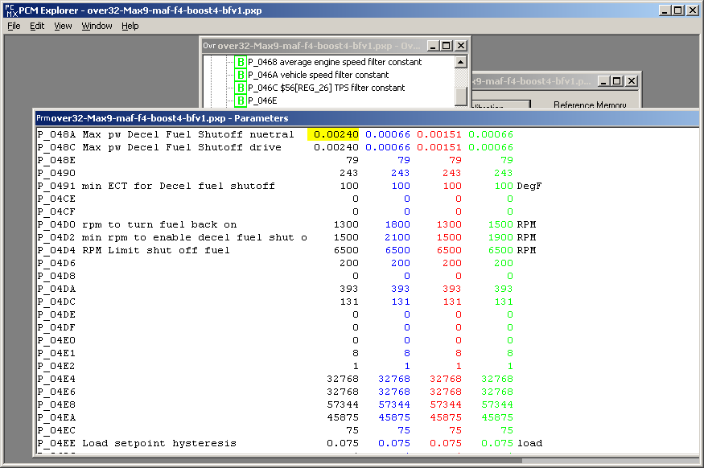

ADDED PARAMETER TO THE PCMX .RDT FILE TO ADJUST JUST STARTED DELAY TO START THE MAF CLIP.

BEGIN PARAM "P_57e1 Delay before maf clip"
ID "P_57e1"
UNITS ""
ADDRESS 0x57E1
TYPE 0x1
SCALE 1.000000
OFFSET 0.000000
FORMAT "%3.0f"
ADJUST 1
ALTADJUST 1
END

Start up Delay for Maf Clip ( stock value is the blue , mine are in the black )

